Hierarchy: Clock, WorldClock

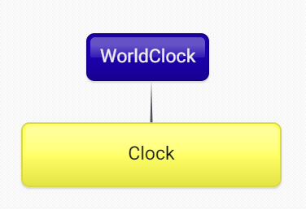

Common Responsibilities:

getTime()

getHours()

getMinutes()

getTime12Hr()

Overridden:

WorldClock.getHours() now returns an hours offset by a given amount.

WorldClock also now constructs with an additional parameter to said offset amount.